**ASSIGNMENT – 2**

Virtual File System

Name – Ashutosh Soni

Id – 2018ucp1505

**Question: On a Linux machine, explore proc virtual file system. Use command (cd /proc). Write a report on what information can be accessed from this file system and how?**

**Answer:**

Proc file System (procfs) is virtual system created on fly when system boots and is dissolved at time of system shut down. It contains the information about the processes that are currently running, it is regarded as control and information centre for the kernel. The proc file system also provides communication medium between kernel space and user space.

Several Linux commands access the information from /proc, and displays in a certain format.

1. /proc Directories with names as numbers

Do a ls -l /proc, and you’ll see lot of directories with just numbers. These numbers represent the process ids, the files inside this numbered directory corresponds to the process with that particular PID.

Following are the important files located under each numbered directory (for each process):

* cmdline – command line of the command.
* environ – environment variables.
* fd – Contains the file descriptors which is linked to the appropriate files.
* limits – Contains the information about the specific limits to the process.
* mounts – mount related information

Following are the important links under each numbered directory (for each process):

* cwd – Link to current working directory of the process.
* exe – Link to executable of the process.
* root – Link to the root directory of the process.

2. /proc Files about the system information

Following are some files which are available under /proc, that contains system information such as cpuinfo, meminfo, loadavg.

* /proc/cpuinfo – information about CPU,
* /proc/meminfo – information about memory,
* /proc/loadvg – load average,
* /proc/partitions – partition related information,
* /proc/version – Linux version

Some of the screenshot related with proc command are as under…

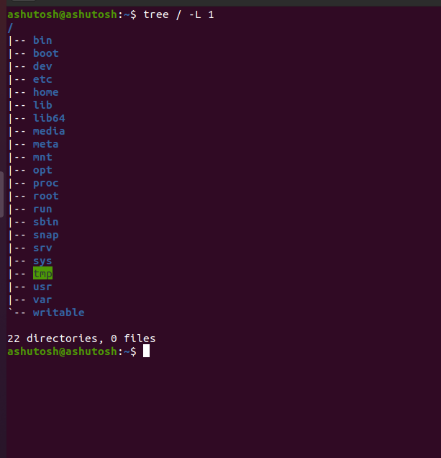Under directory…

Some other screenshots of proc commands containing list…

